

At the far end of town where the Grickle-grass grows

and the wind smells slow-and-sour when it blows

and no birds ever sing excepting old crows...

is the Street of the Lifted Lorax.

And deep in the Grickle-grass, some people say,

if you look deep enough you can still see, today,

where the Lorax once stood just as long as it could

before somebody lifted the Lorax away.

What *was* the Lorax? And why was it there?

And why was it lifted and taken somewhere

from the far end of town where the Grickle-grass grows?

The old Once-ler still lives here. Ask him. *He* knows.

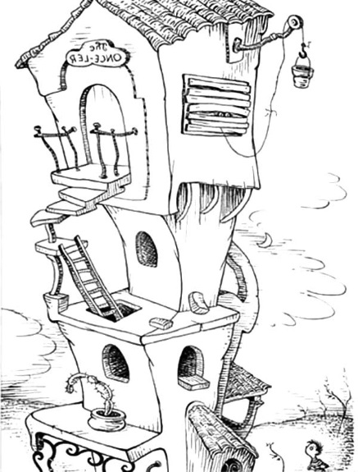

You won't see the Once-ler. Don't knock at his door.

He stays in his Lerkim on top of his store.

He lurks in his Lerkim, cold under the roof,

where he makes his own clothes out of miff-muffered moof.

And on special dank midnights in August, he peeks

out of the shutters and sometimes he speaks

and tells how the Lorax was lifted away.

He'll tell you, perhaps... if you're willing to pay.

On the end of a rope he lets down a tin pail

and you have to toss in fifteen cents and a nail

and the shell of a great-great-great grandfather snail.

Then he pulls up the pail, makes a most careful count

to see if you've paid him the proper amount.

Then he hides what you paid him away in his Snuvv,

his secret strange hole in his gruvvulous glove.



Then he grunts, "I will call you by Whisper-ma-Phone,

for the secrets I tell you are for your ears alone."

*SLUPP!*

Down slupps the Whisper-ma-Phone to your ear

and the old Once-ler's whispers are not very clear,

since they have to come down through a snergelly hose,

and he sounds as if he had smallish bees up his nose.

"Now I'll tell you, "he says, with his teeth sounding gray,

"how the Lorax got lifted and taken away...

It all started way back... such a long, long time back...

Way back in the days when the grass was still green

and the pond was still wet and the clouds were still clean,

and the song of the Swomee-Swans rang out in space...

one morning, I came to this glorious place.

And I first saw the trees! The Truffula Trees!

The bright-colored tufts of the Truffula Trees!

Mile after mile in the fresh morning breeze.

And, under the trees, I saw Brown Bar-ba-loots

frisking about in their Bar-ba-loot suits

as they played in the shade and ate Truffula fruits.

From the rippulous pond came the comfortable sound

of the Humming-Fish humming while splashing around.

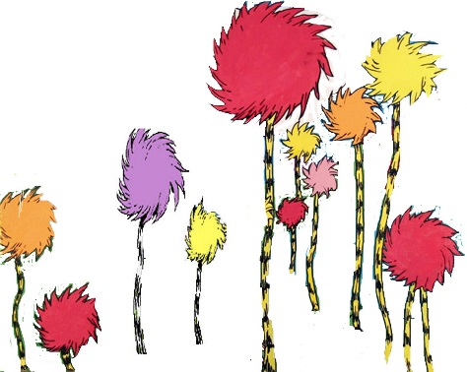  
But those *trees!* Those *trees! Those Truffula Trees!*

All my life I'd been searching for trees such as these.

The touch of their tufts was much softer than silk.

And they had the sweet smell of fresh butterfly milk.

I felt a great leaping of joy in my heart.

I knew just what I'd do! I unloaded my cart.

In no time at all, I had built a small shop.

Then I chopped down a Truffula Tree with one chop.

And with great skillful skill and with great speedy speed,

I took the soft tuft, and I knitted a Thneed! The instant I'd finished, I heard a *ga-Zump!*

I looked. I saw something pop out of the stump

of the tree I'd chopped down. It was sort of a man.

Describe him?... That's hard. I don't know if I can.

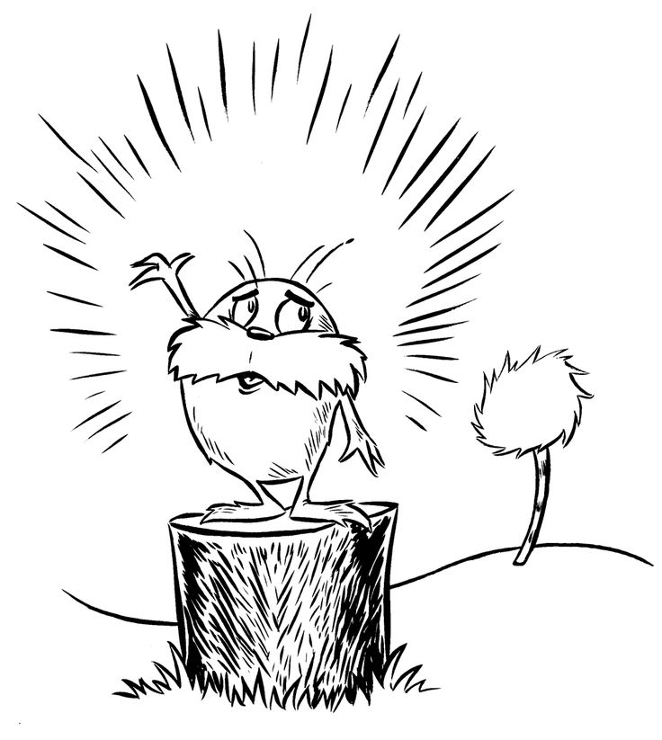

He was shortish. And oldish. And brownish.

And mossy. And he spoke with a voice

that was sharpish and bossy.

"Mister!" he said with a saw dusty sneeze,

"I am the Lorax. I speak for the trees.

I speak for the trees, for the trees have no tongues.

And I'm asking you, sir, at the top if my lungs"-

he was very upset as he shouted and puffed-

*"What's that THING you've made out of my Truffula tuft?"*

"Look, Lorax," I said.   
"There's no cause for alarm. I chopped just one tree.

I am doing no harm. I'm being quite useful. This thing is a Thneed.

A Thneed's a Fine-Something-That-All-People-Need!

It's a shirt. It's a sock. It's a glove, It's a hat.

But it has *other* uses. Yes, far beyond that.

You can use it for carpets. For pillows! For sheets!

Or curtains! Or covers for bicycle seats!"

The Lorax said, "Sir! You are crazy with greed.

There is no one on earth who would buy that fool Thneed!"

But the very next minute I proved he was wrong.

For, just at that minute, a chap came along,

and he thought the Thneed I had knitted was great.

He happily bought it for three ninety-eight

I laughed at the Lorax, "You poor stupid guy!

You never can tell what some people will buy."

"I repeat," cried the Lorax, "I speak for the trees!"

"I'm busy," I told him. "Shut up, if you please."

I rushed 'cross the room, and in no time at all,

built a radio-phone. I put in a quick call.

I called all my brothers and uncles and aunts

and I said, "Listen here! Here's a wonderful chance

for the whole Once-ler Family to get mighty rich!

Get over here fast! Take the road to North Nitch.

Turn left at Weehawken. Sharp right at South Stitch."

And, in no time at all, in the factory I built,

the whole Once-ler Family was working full tilt.

We were all knitting Thneeds just as busy as bees,

to the sound of the chopping of Truffula Trees.

Then...Oh! Baby! Oh! How my business did grow!

Now, chopping one tree at a time was too slow.

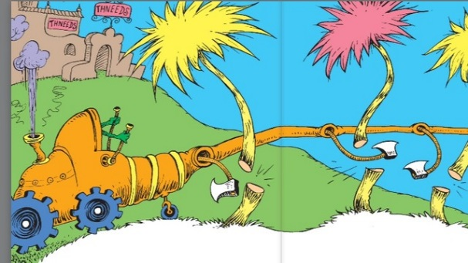

So I quickly invented my Super-Axe-Hacker,

which whacked off four Truffula Trees at one smacker.

We were making Thneeds four times as fast as before!

And that Lorax?... *He* didn't show up any more.

But the next week

he knocked on my new office door.

He snapped, "I am the Lorax who speaks for the trees

which you seem to be chopping as fast as you please.

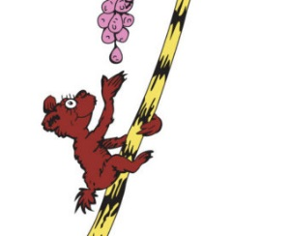  
But I'm *also* in charge of the Brown Bar-ba-loots who played in the shade in their Bar-ba-loot suits and happily lived, eating Truffula Fruits.

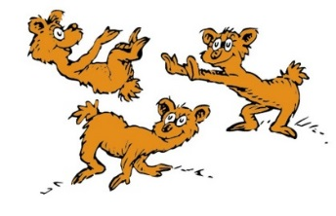

"NOW... thanks to your hacking my trees to the ground, there's not enough Truffula Fruit to go 'round. And my poor Bar-ba-loots are all getting the crummiest, because they have gas, and no food, in their tummies!

"They loved living here. But I can't let them stay.

They'll have to find food. And I hope that they may.

Good luck, boys," he cried. And he sent them away.

I, the old Once-ler, felt sad as I watched them all go.

BUT... business is business! And business must grow

regardless of crummies in tummies, you know.

I meant no harm. I most truly did not.

But I had to grow bigger. So bigger I got.

I biggered my factory. I biggered my roads.

I biggered my wagons. I biggered the loads

of the Thneeds I shipped out.   
I was shipping them forth

to the South! To the East! To the West! To the North!  
I went right on biggering... selling more Thneeds.

And I biggered my money, which everyone needs.

Then *again* he came back! I was fixing some pipes

when that old-nuisance Lorax   
came back with *more* gripes.

"I am the Lorax," he coughed and he whiffed.

He sneezed and he snuffled. He snarggled.

He sniffed.

"Once-ler!" he cried with a cruffulous croak.

"Once-ler! You're making such smogulous smoke!

My poor Swomee-Swans... why,

they can't sing a note!

No one can sing who has smog in his throat.

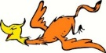Image result for barbaloots clipartImage result for barbaloots clipart"And so," said the Lorax, “please pardon my cough   
they cannot live here. So I'm sending them off.

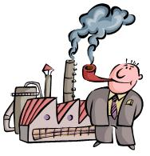"Where will they go?.. I don't hopefully know.

They may have to fly for a month... or a year...

To escape from the smog you've smogged up around here.

"What's *more*," snapped the Lorax.   
(His dander was up.)

"Let me say a few words about Gluppity-Glupp.

Your machine chugs on, day and night without stop

making Gluppity-Glupp.   
Also Schloppity-Schlopp.

And what do you do with this leftover goo?...

I'll show you. You dirty old Once-ler man, you!

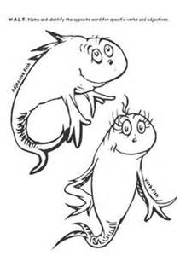"You're glumping the pond where the Humming-Fish hummed!

No more can they hum, for their gills are all gummed.

So I'm sending them off. Oh, their future is dreary.

They'll walk on their fins and get woefully weary

in search of some water that isn't so smeary."

And then I got mad.   
I got terribly mad.

I yelled at the Lorax, "Now listen here, Dad!

All you do is yap-yap and say, 'Bad! Bad! Bad! Bad!'

Well, I have my rights, sir, and I'm telling *you*

I intend to go on doing just what I do!

And, for your information, you Lorax, I'm figgering

On biggering and BIGGERING

andBIGGERING

and BIGGERING,

turning MORE Truffula Trees into Thneeds

which everyone, EVERYONE, *EVERYONE* needs!"

And at that very moment, we heard a loud whack!

From outside in the fields came a sickening smack

of an axe on a tree. Then we heard the tree fall.

*The very last Truffula Tree of them all!*

No more trees. No more Thneeds.

No more work to be done.

So, in no time, my uncles and aunts,

every one, all waved me good-bye.

They jumped into my cars

and drove away under the smoke-smuggered stars.

Now all that was left 'neath the bad smelling-sky

was my big empty factory... the Lorax... and I.

The Lorax said nothing. Just gave me a glance...

just gave me a very sad, sad backward glance...

as he lifted himself by the seat of his pants.

And I'll never forget the grim look on his face

when he heisted himself and took leave of this place,

through a hole in the smog, without leaving a trace.

And all that the Lorax left here in this mess

was a small pile of rocks, with one word...

"UNLESS."

Whatever *that* meant, well, I just couldn't guess.

That was long, long ago. But each day since that day

I've sat here and worried and worried away.

Through the years, while my buildings I've worried about it with all of my heart.

"But *now*," says the Once-ler,

"Now that *you're* here,

the word of the Lorax seems perfectly clear.

UNLESS someone like you cares a whole awful lot,

nothing is going to get better.

It's not.”

"SO...Catch!" calls the Once-ler.

He lets something fall.

"It's a Truffula Seed. It's the last one of all!

You're in charge of the last of the Truffula Seeds.

And Truffula Trees are what everyone needs.

Plant a new Truffula. Treat it with care.

Give it clean water. And feed it fresh air.

Grow a forest. Protect it from axes that hack.

Then the Lorax and all of his friends may come back."

“



